RAG
RAG (Retrieval-Augmented Generation) is a technique that makes Large Language Models (LLMs) more accurate by allowing them to retrieve relevant information from external sources before generating an answer.
Think of it like this:
- Without RAG: The AI answers only from what it learned during training.
- With RAG: The AI first looks up relevant documents, then uses those documents to answer your question.
Why do we need RAG?
LLMs have limitations:
- They may not know recent information.
- They can "hallucinate" (make up facts).
- They don't automatically know your company's internal documents.
RAG solves these by connecting the LLM to external knowledge such as:
- PDFs
- Company documentation
- Databases
- Websites
- Emails
- Knowledge bases

How RAG works
Imagine you ask:
"What is our company's leave policy?"
Instead of guessing, a RAG system performs these steps:
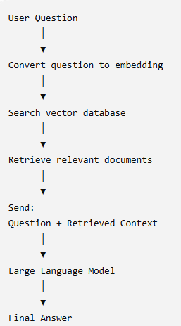
Step-by-step example
Suppose your company has an employee handbook.
Step 1: Store documents
The handbook is split into smaller chunks.
Example:
Chunk 1:
Employees receive 20 paid leave days annually.
Chunk 2:
Medical leave requires manager approval.

Step 2: Create embeddings
Each chunk is converted into a numerical vector using an embedding model.
Example:
Chunk:
"Employees receive 20 paid leave days"
↓
Embedding
[0.23, -0.55, 0.81, ...]
These vectors are stored in a vector database.
Popular vector databases:
- Pinecone
- ChromaDB
- FAISS
- Weaviate
- Milvus
- Qdrant

Step 3: User asks a question
How many leave days do employees get?
This question is also converted into an embedding.

Step 4: Similarity search
The vector database finds chunks whose embeddings are most similar.
Retrieved chunk:
Employees receive 20 paid leave days annually.

Step 5: Give context to the LLM
Instead of asking only:
How many leave days do employees get?
the prompt becomes:
Context:
Employees receive 20 paid leave days annually.

Question:
How many leave days do employees get?
Now the model answers:
Employees receive 20 paid leave days annually.
This is much more reliable because it's grounded in retrieved information.

What are embeddings?
Embeddings convert text into vectors that capture meaning.
For example:
Sentence | Meaning
Car | Vehicle
Automobile | Vehicle
Bike | Two-wheeler
Although "car" and "automobile" use different words, their embeddings are close together because they have similar meanings.
This enables semantic search, where results are based on meaning rather than exact keyword matches.
What is a vector database?
A vector database stores embeddings and quickly finds the most similar ones.
Example:
Question embedding
│
▼
Vector DB

Document A ← Similarity = 0.93
Document B ← Similarity = 0.88
Document C ← Similarity = 0.22
The most relevant documents are returned.

Complete RAG architecture
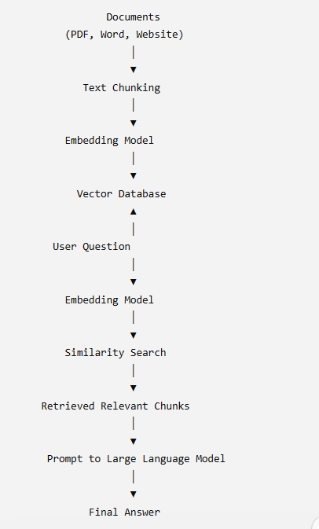

Advantages of RAG
- More accurate answers
- Reduces hallucinations
- Access to up-to-date information
- Uses private/company data without retraining the model
- More cost-effective than fine-tuning for many knowledge-based tasks

RAG vs Fine-tuning
RAG | Fine-tuning
Retrieves external information | Changes the model's learned behavior
Easy to update knowledge | Requires retraining to update knowledge
Good for documents and FAQs | Good for changing style, tone, or specialized tasks
Lower cost | Higher cost and more maintenance
A useful rule of thumb:
- Need the model to know new or changing information? Use RAG.
- Need the model to behave differently (e.g., adopt a specific writing style or follow specialized patterns)? Consider fine-tuning.

Real-world applications
- Customer support chatbots
- Enterprise document search
- Legal document assistants
- Medical knowledge assistants
- Financial report analysis
- Research assistants
- Internal company Q&A systems
- Educational tutors

Simple analogy
Imagine you're taking an open-book exam.
- Without RAG: You answer from memory.
- With RAG: Before answering, you quickly look up the relevant pages in the textbook and then write your response based on what you found.
That's exactly what RAG does: it retrieves the most relevant information first, then generates an answer using that information.
If you're interested in building one, a typical Python RAG stack is:
- Load documents (PDFs, websites, etc.).
- Split them into chunks.
- Generate embeddings (e.g., with OpenAI or sentence-transformer models).
- Store embeddings in a vector database (e.g., FAISS, ChromaDB, Pinecone).
- Retrieve the most relevant chunks for each user query.
- Pass the retrieved context and the query to an LLM to generate the final answer.

MULTI AGENTS
Multi-Agent Systems
A multi-agent system is an AI system where multiple AI agents work together, with each agent having a specific role or responsibility.
Instead of asking one AI to do everything, we divide the task among specialized agents.
Simple example
Suppose a customer asks:
"Find me the best laptop under ₹60,000 and compare prices."
A multi-agent system could work like this:
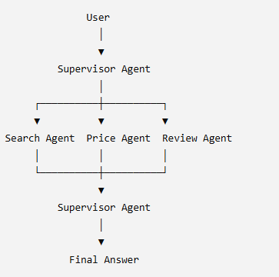
What each agent does
1. Supervisor Agent
- Understands the user's request.
- Decides which agents are needed.
- Assigns tasks.
- Combines their results.
2. Search Agent
- Searches products from available sources.
- Finds relevant products and links.
3. Price Agent
- Compares prices.
- Finds the cheapest option.
4. Review Agent
- Analyzes ratings and reviews.
- Helps determine product quality.
The supervisor then combines everything and gives the customer one final answer.

Single Agent vs Multi-Agent
Single Agent | Multi-Agent
One agent handles everything | Multiple specialized agents
Simpler architecture | More complex architecture
Can become overloaded | Tasks are distributed
Less specialization | Each agent can specialize
Good for simple tasks | Good for complex tasks

Why use Multi-Agent Systems?
The main idea is specialization + collaboration.
For example:
Agent 1 → Search
Agent 2 → Analysis
Agent 3 → Pricing
Agent 4 → Recommendation
Agent 5 → Final response
Each agent focuses on what it is best at.

In your SmartCart project
Your project is actually a good example for understanding multi-agent architecture.
You could have:
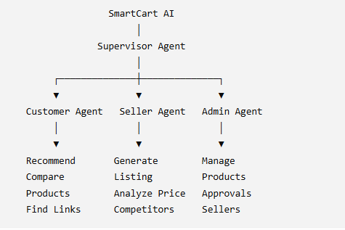

For example, when a seller enters:
"I want to sell wireless headphones."
The Seller Agent could delegate:
Seller Agent
│
├── Product Listing Agent
│ └── Title + Description
│
├── Competitor Agent
│ └── Competitor prices
│
├── Pricing Agent
│ └── Suggested selling price
│
└── Image Agent
└── Image generation
This is where RAG + Multi-Agent + LLM can become powerful:
RAG → gives agents relevant knowledge
Tools/APIs → allow agents to perform actions
Multi-Agent system → divides and coordinates the work
LLM → provides reasoning and natural-language generation
So, in one line:
Multi-agent AI = multiple specialized AI agents collaborating to complete a complex task.

